CTM-I Test Plan

Menu Tab: Firm Maintenance

Screen: Firm Authorization

Version 0.1

Menu Tab: Firm Maintenance

Use Case Name | Firm Authorization
User Roles | Firm User(CTMI_Firm_Options_Root, CTMI_Firm_Options_Admin), Market Ops(CTMI_Help_Desk), Ops(CTMI_Systems), App Support(CTMI_Root)
Pre-conditions /Assumptions | User has successfully logged into the CTM-I application.
Post Conditions | None
Screenshot | 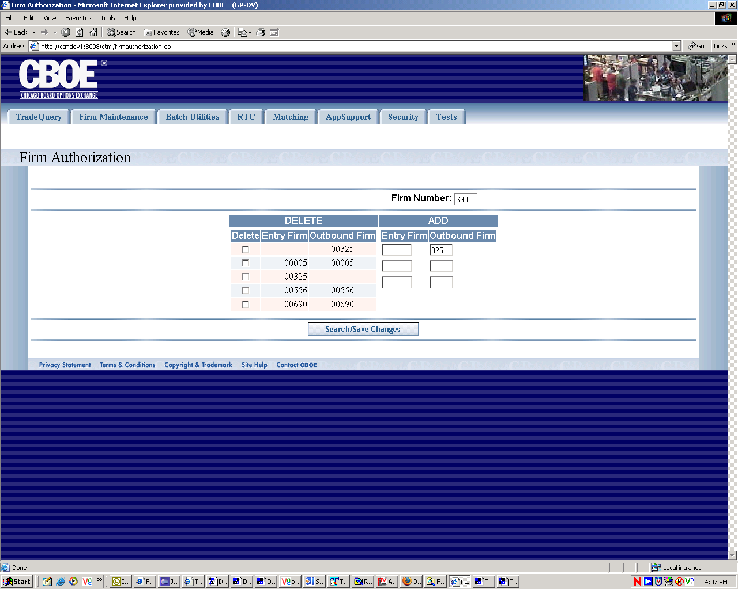
Test Scenario A | User Role : CTMI_Firm_Options_Root, User Id: xxx Password: xxx
 | Action | Expected Out Come | Comments/Results
Test Case 1  Display Authorization Screen | User Clicks on Firm Authorization Menu | Firm Authorization Screen Displays Entry Firm and Outbound Firm data for the Primary Firm on the Authorization Column and three sets of blank text fields on the Add column. Firm Number field at the top becomes a drop down list populated with all the Primary Firms for this user.
Test Case 2  Search | User Selects a Firm Number in the named field and Clicks Save/Search button. | On ‘Authorized Firms’ Column Screen Displays existing firms meeting the search criteria with ‘Delete’ checkbox on each row.  On Add Column text fields for entering firm data appear in 3 rows | Alternate Flow  If no matching firms exist no rows are returned.  All rows are returned on the same page. May have to scroll down for large amount of data rows.
Test Case 3  Delete | User Selects firms to be deleted (Check Box marked). And Clicks Save/Search button | The rows with marked checkbox are deleted. | Alternate Flow  If ‘Delete’ is successful
 |  | Error Message appears on the screen if ‘delete’ fails for some reason. | Alternate Flow  If ‘Delete’ fails
Test Case 4  Add | User enters firm data in one or more rows on the Add column and Clicks Save/Search button | Firms are added to the database and these new firms are displayed on the ‘Authorized Firms’ Column. | Alternate Flow  If additions are successful only.
 | User enters a firm which already exits and Clicks Save/Search button | Addition fails - Entry Authorized Firm already exists | Alternate Flow
 | User enters a serving firm which has no operator and Clicks Save/Search button | Addition fails - Serving Firm has no operators | Alternate Flow
 | User enters a serving firm which does not exist in the System and Clicks Save/Search button | Addition fails - Serving Firm has no operators | Alternate Flow  Error Message Should say ‘Firm does not exist’
 | User enters an outbound firm which has no operators and Clicks Save/Search button | Addition fails - Outbound Firm has no operators | Alternate Flow
 | User enters an outbound firm which does not exist and Clicks Save/Search button | Addition fails - Serving Firm has no operators | Alternate Flow  Error Message Should say ‘Firm does not exist’
 | User Enters Valid Outbound Firm Only and Clicks Save/Search button | Addition fails - Error Message | Alternate Flow  If Blank Entry Firm already exists.
 | User Enters Valid Outbound Firm Only and Clicks Save/Search button | Addition Successful – Displays on the Authorized Column. | Alternate Flow  If Blank Entry Firm does not already exist
 | User enters firms with alpha character (not all numeric) | Error Message – Only numeric characters permitted. | Does require client side syntactic validation? Use case does not specify.
 | User Enters less than 3 digit number for firms | Left Padded with 0 to make it 3 digit number. | Does require client side syntactic validation? Use case does not specify.
 | User enters more than 3 digit numbers | Error Message - Only up to 3 digits are allowed | Does require client side syntactic validation? Use case does not specify.
 | User enters Entry and Outbound Firms on Multiple Rows (some valid and some invalid) and clicks Save/Search button | Valid rows are added and displayed on the list on the Authorized Firms Columns.  Invalid Rows are errored on the screen. | Currently processing is stopped after an unsuccessful transaction even though valid entries are there for addition.  Bruce will talk to Calvin to see how this could be implemented.
 | User selects multiple rows for deletion and clicks Save/Search button | Deleted Rows are removed from display on the screen.
 | User enters multiple (some valid and some invalid) Entry Firms and Outbound Firms on add Column and Selects Multiple Rows for Deletion and clicks Save/Search button | Valid rows are added and displayed on the list on the Authorized Firms Columns.  Deleted Rows are removed from display on the screen.  Invalid Rows are errored on the screen. | Currently processing is stopped after an unsuccessful transaction even though valid entries are there for addition.  Bruce will talk to Calvin to see how this could be implemented.
Test Scenario B | Repeat above test cases with login with diff user roles namely Ops (CTMI_Firm_Options_Admin)  User Id: xxx Password: xxx
 | All Test Cases Same as Test Scenario A
Test Scenario C | Repeat above test cases with login with diff user roles namely  AppSupport(CTMI_Root) User Id: xxx Password: xxx
 | User Clicks on Firm Authorization Menu | Firm Authorization Screen Displays without any data on the Authorized Firms Column and three sets of blank text fields on the Add column. Firm Number field at the top becomes text box populated with 000 user.
 | Rest Same as Test Scenario A
Test Scenario D | Repeat above test cases with login with diff user roles namely AppSupport (CTMI_Systems)  User Id: xxx Password: xxx
 | Same as Test Scenario C
Test Scenario E | Repeat above test cases with login with diff user roles namely AppSupport (CTMI_Help_Desk)  User Id: xxx Password: xxx
 | Same as Test Scenario C

